**The Independent**

**9.1.15**

**World Pooh Sticks Championships in desperate need of a new home as popularity grows**

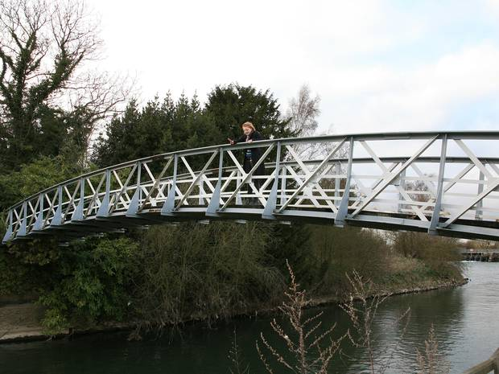

**‘Bother,’ Pooh told Piglet. ‘We need a bigger bridge’**

Should you own a plot of land through which runs a river crossed by a bridge – with ample space for nearby parking – you could well be the saviour of a particularly British institution.

The World Pooh Sticks Championships is in desperate need of a new home. With up to 2,000 visitors – from as far afield as Japan, Kenya and Australia – the annual event has outgrown its current site at Days Lock in Little Wittenham, Oxfordshire. “It’s always been a popular event but it’s grown in the past few years,” said Karen Eveleigh, of organising body the Oxford Spires Rotary Club. “And it’s a very small village with a narrow lane down to the bridge.” With March – the month in which the championship is traditionally held – fast approaching, Ms Eveleigh admits the 2015 event may be a makeshift affair.

The requirements for the club’s ideal venue are particular. As well as a bridge to hold six competitors side-by-side and parking for 300 cars, space is needed for a registration tent, a tea and cake stall and, ideally, village fete games. “It’s difficult, because you see a nice river in an area that looks pretty and you think ‘OK, is there parking nearby?’” she said. “And if it’s a part of the river where there is a lot of boat traffic then we couldn’t run it during the summer.”

On championship day, competitors drop coloured sticks off one side of a bridge with the owner of the first to reach the finishing line – roughly 5m (16ft) downstream – crowned winner. After three or four heats, the day culminates with a grand final. “So the excitement really grows,” said Ms Eveleigh.

Joss Croft, marketing director at VisitBritain, commended the event for its “quirkiness”. “A touch of quirkiness is part of the British experience,” he said. “Britain is truly unique and this extends to the country’s hugely varied range of attractions that inspire and delight our international visitors.”

The game was invented by  A A Milne, the author of Winnie the Pooh, who featured it for the first time in The House at Pooh Corner.

Originally played near Milne’s home in Ashdown Forest, Pooh Sticks became associated with Oxfordshire when a local lock keeper organised an event to raise funds for the RNLI. Stewardship was passed to the Oxford Spires Rotary Club in 2009.

<http://www.independent.co.uk/news/weird-news/world-pooh-sticks-championships-in-desperate-need-of-a-new-home-as-popularity-grows-9966285.html>